AWS Assessment Project 4

Project: Git Project

**TASK 1: Create a repository in GitHub**

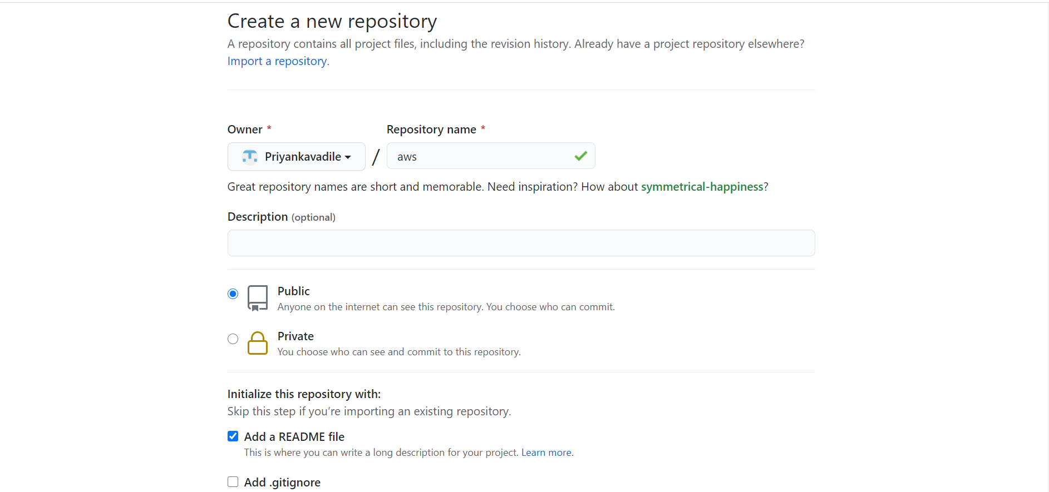

* **Open git bash and clone the contents from remote repository.**
* **Create a new folder and call in git bash in the folder.**

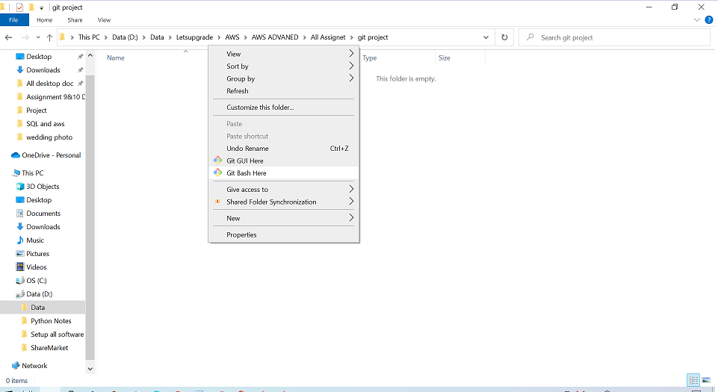

• git init

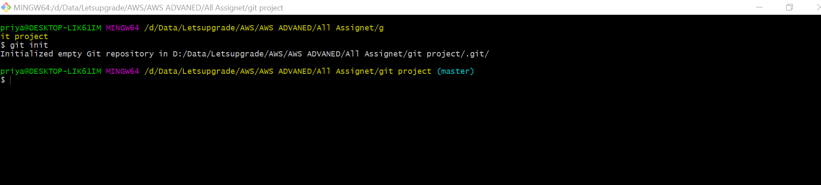

• Config Commands

Git config –-global user.email (user email)

Git config –-global user.name (user name)

Git clone (paste the url of the repo)

Ls

Cd \newrepo

Touch test.txt

Ls

Git status

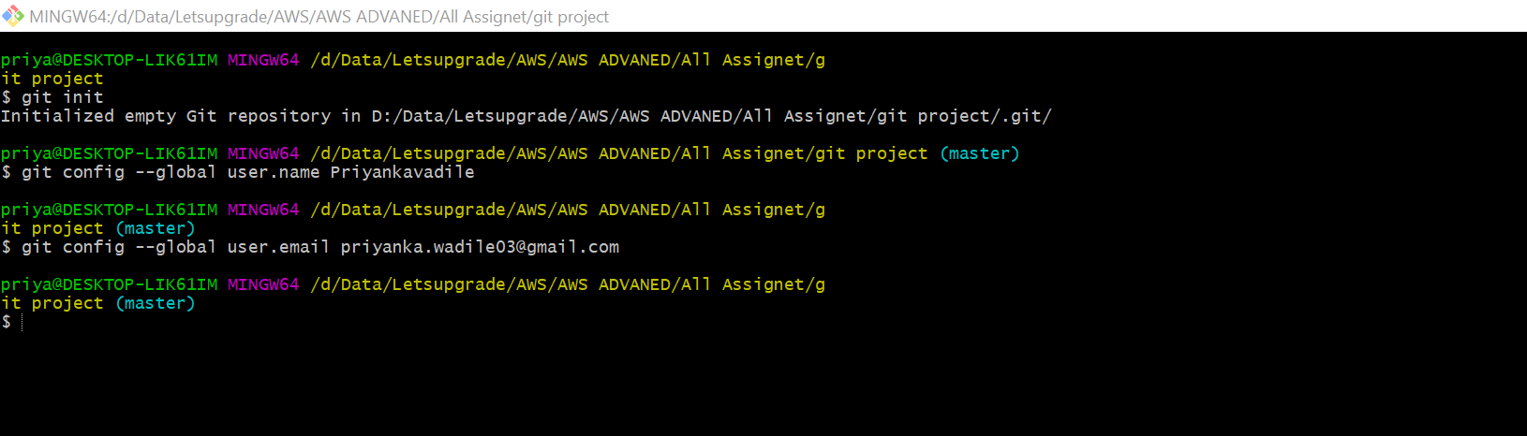

**TASK 2: open git bash and clone contents from remote repository**

**First copy the url from GitHub remote repository “aws”.**

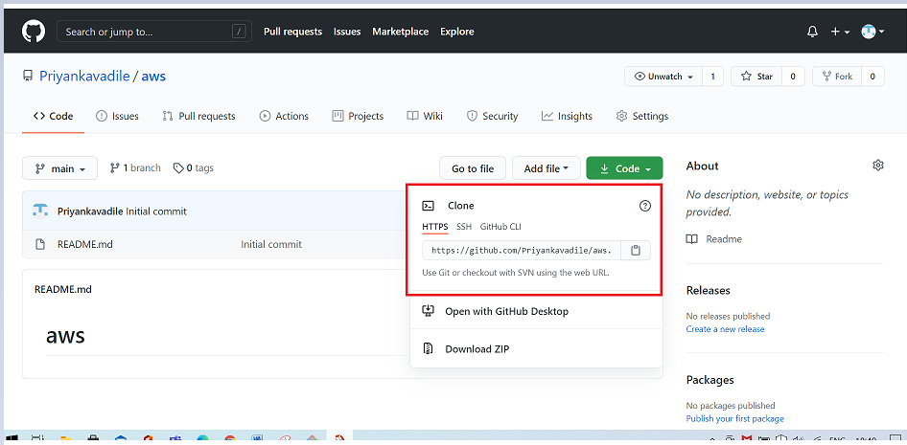

[**https://github.com/Priyankavadile/aws.git**](https://github.com/Priyankavadile/aws.git)

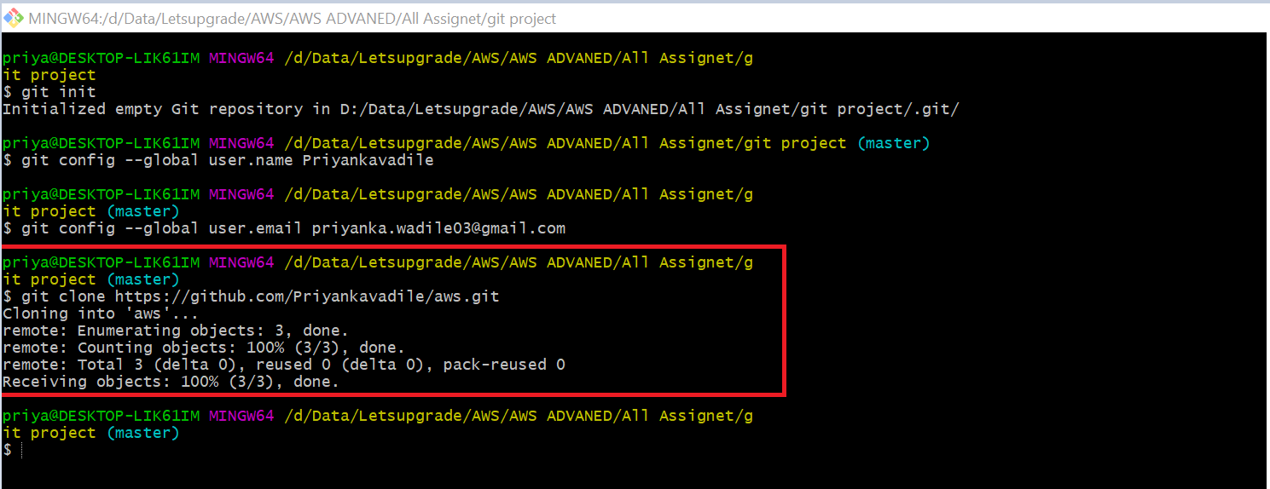

**Show the folder in local repository**

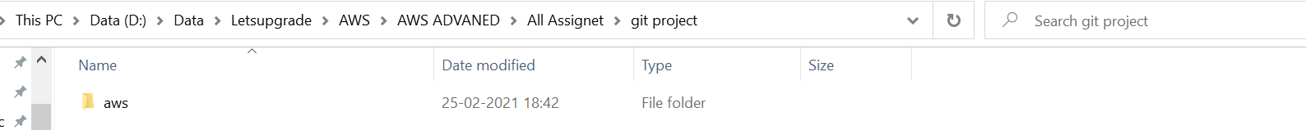

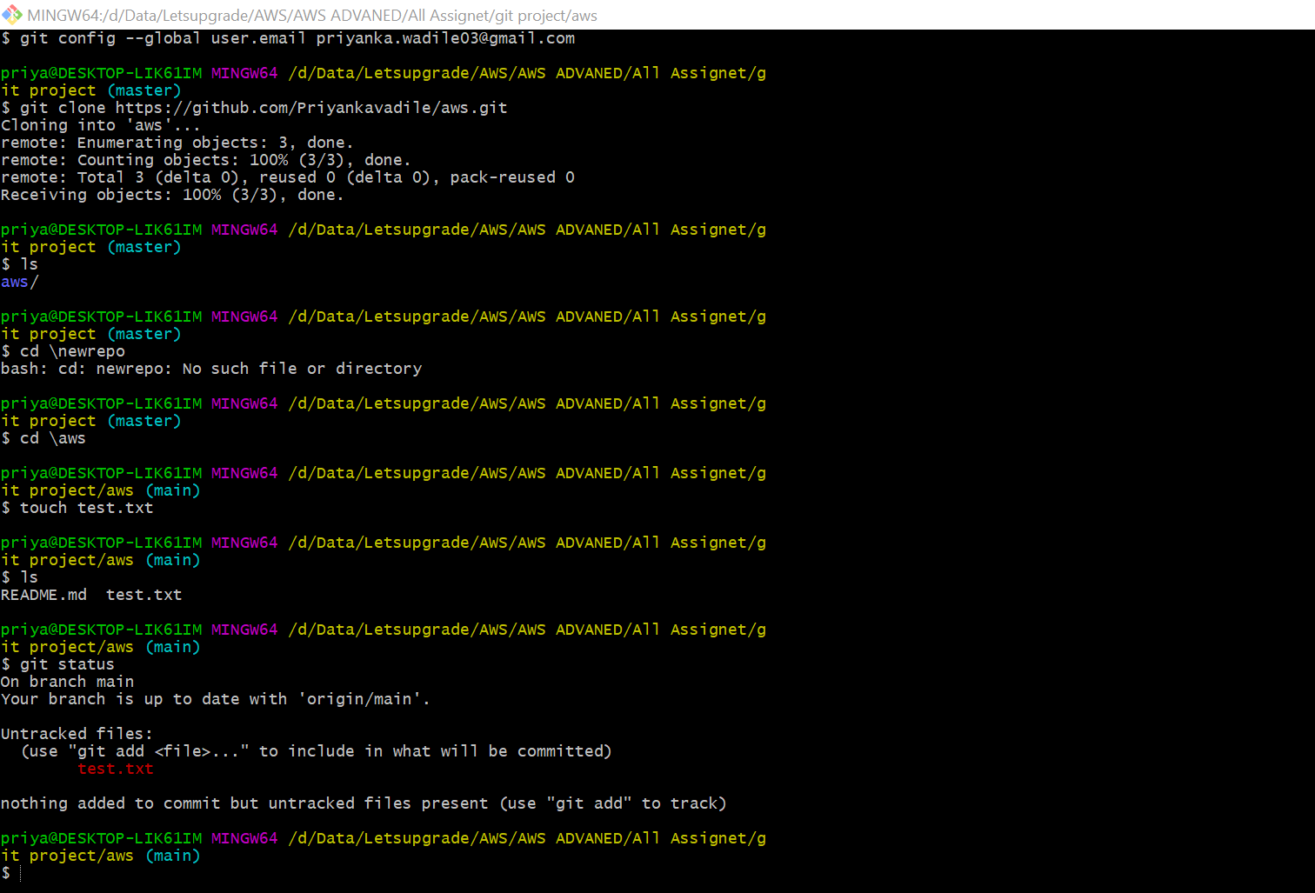

* **Create a file in the local space and push it to the remote repository.**

Follow the command:

Git add test.txt

Git status

Git commit -m “first commit” test.txt

Git status

Git push -u origin main

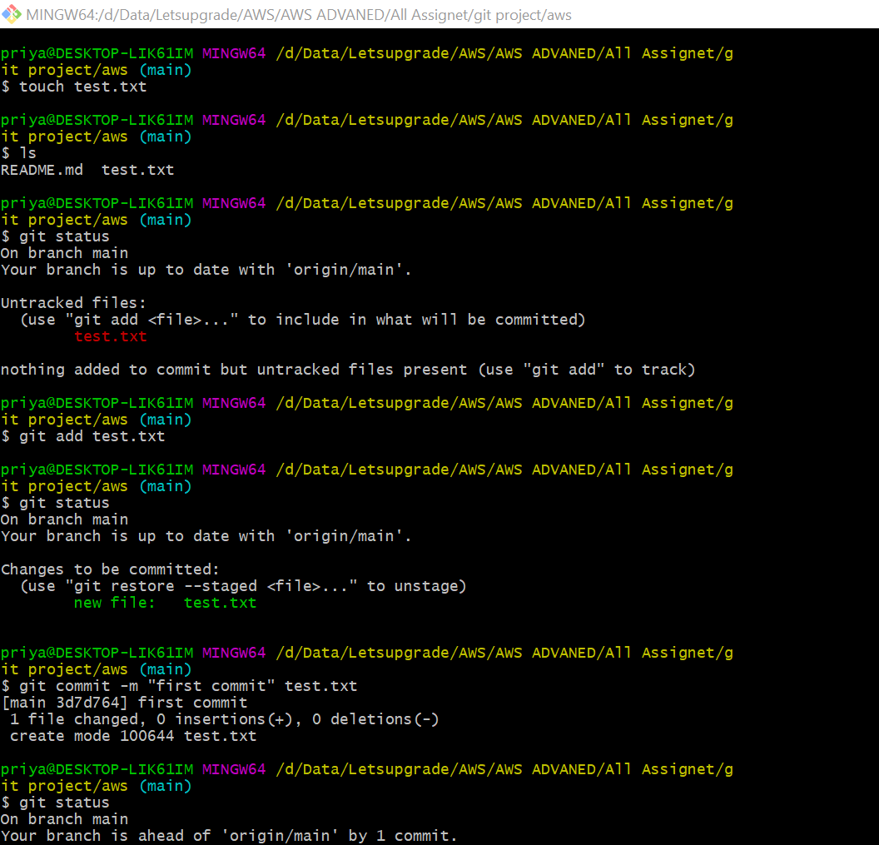

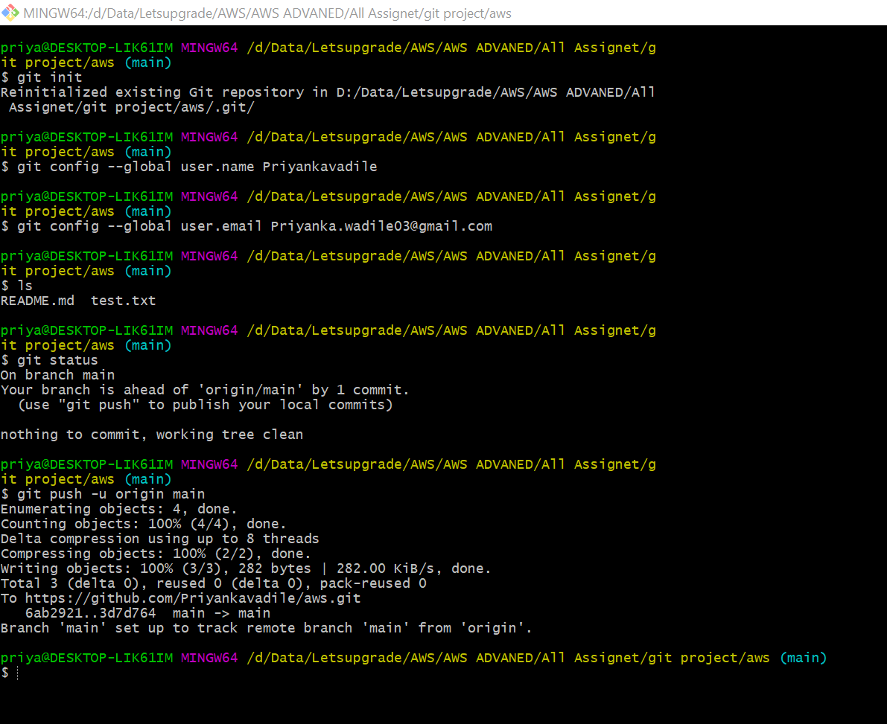

* **Show the file in the remote repository.**

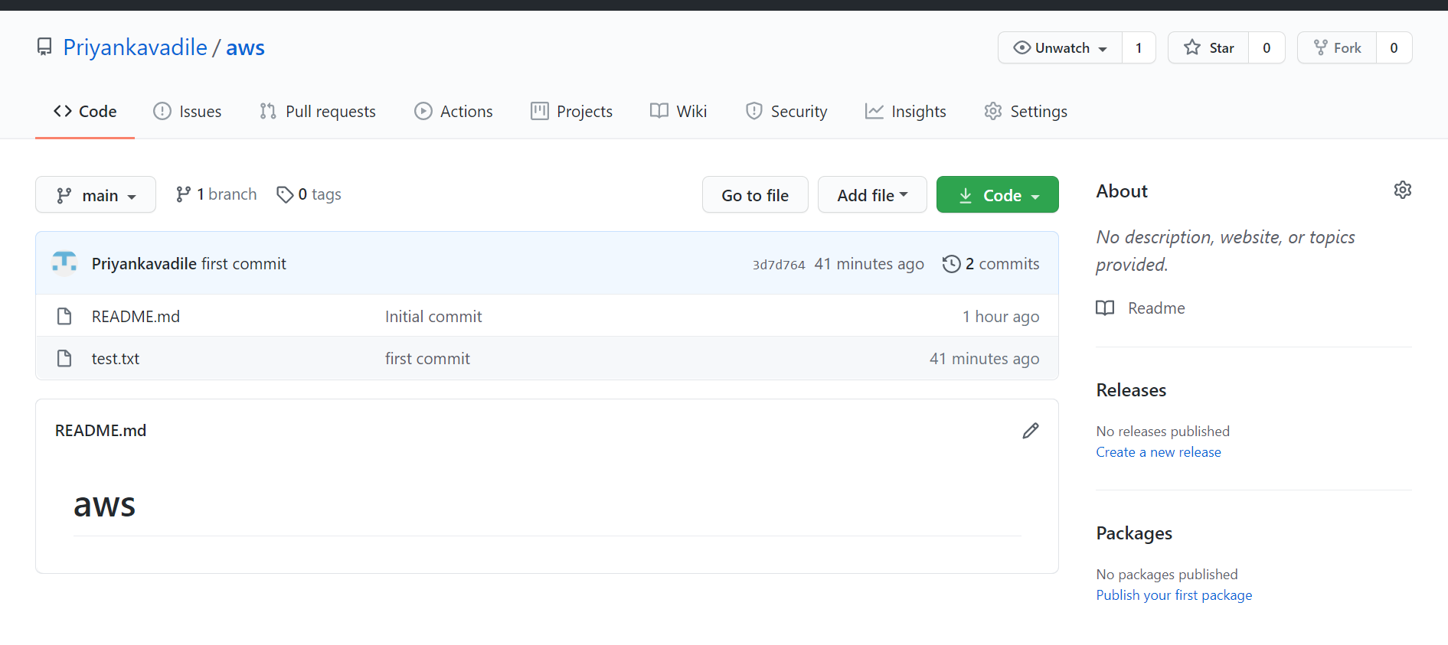

* Git branching and merging.

Git branch: to show branches

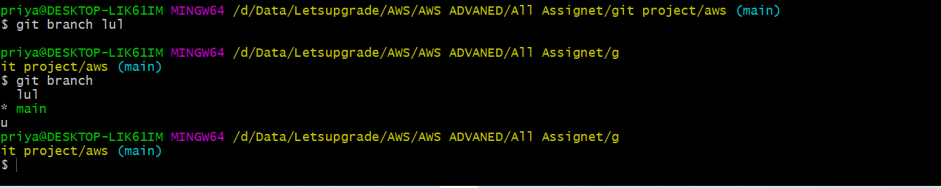

* **Git checkout branch name: switch to next branch**



* **Git merge branch name: to merge the branches**



* **Git branch -d branch name: to delete the branch**

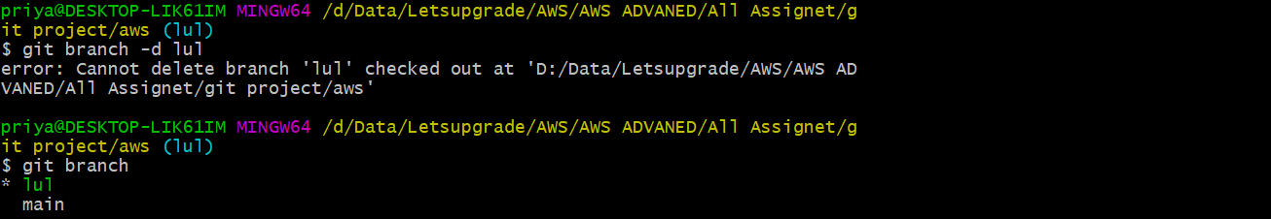



* **Git log: gives the details of the repository.**

